**Project Report Format**

1. **INTRODUCTION**

**1.1 Project Overview**

Employ Tableau to delve into Toy Manufacturers' data, uncovering market trends, production  
patterns, and consumer preferences. Craft interactive visualizations to guide strategic decisions and enhance market competitiveness  
The Toy Manufacturers' Data Exploration and Visualization Project aims to leverage the power of Tableau to provide a comprehensive analysis of the toy manufacturing industry. By delving into the vast dataset encompassing various facets of the industry, the project seeks to uncover valuable insights related to market trends, production patterns, and consumer preferences.Utilize Tableau to dissect market trends within the toy manufacturing sector. Explore historical sales data, identify emerging market demands, and highlight patterns that can inform strategic decisions. By visualizing market dynamics over time, the project aims to offer a deep understanding of the industry's evolution.Analyze consumer behavior and preferences by examining data related to popular toy categories, demographic trends, and purchasing patterns. Develop interactive visualizations that highlight consumer preferences, enabling manufacturers to align their product offerings with market demands. This insight is crucial for tailoring product development strategies to meet customer expectations.

**1.2 Purpose**

Scenario 1:  
Market Trend Analysis for Seasonal Products: The project could delve into historical sales data for different types of toys across various seasons and holidays. By visualizing the sales trends over the years, manufacturers can identify patterns in consumer preferences during specific times of the year. For instance, they might find that certain types of toys sell better during the holiday season, while others have higher demand during summer months. Armed with this insight, toy manufacturers can adjust their production schedules and marketing strategies accordingly to   
maximize sales and meet seasonal demands effectively.  
Scenario 2:  
  
Consumer Preference Analysis Across Demographics: Using demographic data such as age, gender, and location, the project could analyze consumer preferences for different types of toys. Interactive visualizations can be created to show how preferences vary among different demographic groups. For example, it might reveal that teenagers in urban areas have a higher preference for electronic toys, while younger children in rural areas prefer traditional toys such as dolls and action figures. This information can help manufacturers tailor their product offerings and marketing campaigns to target specific demographic segments more effectively.  
Scenario 3:  
  
Product Performance Comparison Across Regions: By analyzing sales data across different regions or countries, the project could identify which toy categories perform better in certain geographic areas. For instance, it might find that educational toys are more popular in regions with a strong emphasis on education, while outdoor toys sell better in areas with favorable weather conditions. Visualizations could illustrate these regional differences in demand, allowing manufacturers to optimize their distribution channels and inventory management strategies to better serve each market.

2. **IDEATION PHASE**

**2.1 Problem Statement**

**Customer Problem Statement Template:**

**Definition:**

**Toycraft Tales Tableau Vision Manufactures Data**

It is the process of transforming raw toy manufacturing data—such as production costs, material waste, and assembly line efficiency—into interactive visual dashboards. Using Tableau, this vision aims to "tell a story" (Tales) through data, making complex manufacturing metrics easy to understand for stakeholders.

**Purpose of Analyzing Toy Manufacture Data**

* Operational Efficiency: To identify bottlenecks in the production line where toy assembly might be slowing down.
* Quality Control: To track defect rates across different toy categories and improve the manufacturing standards.
* Cost Management: To analyze the cost of raw materials (plastic, fabric, electronics) and find ways to reduce waste without compromising quality.
* Market Alignment: To see which toy designs are performing best in the market and adjust production schedules accordingly.

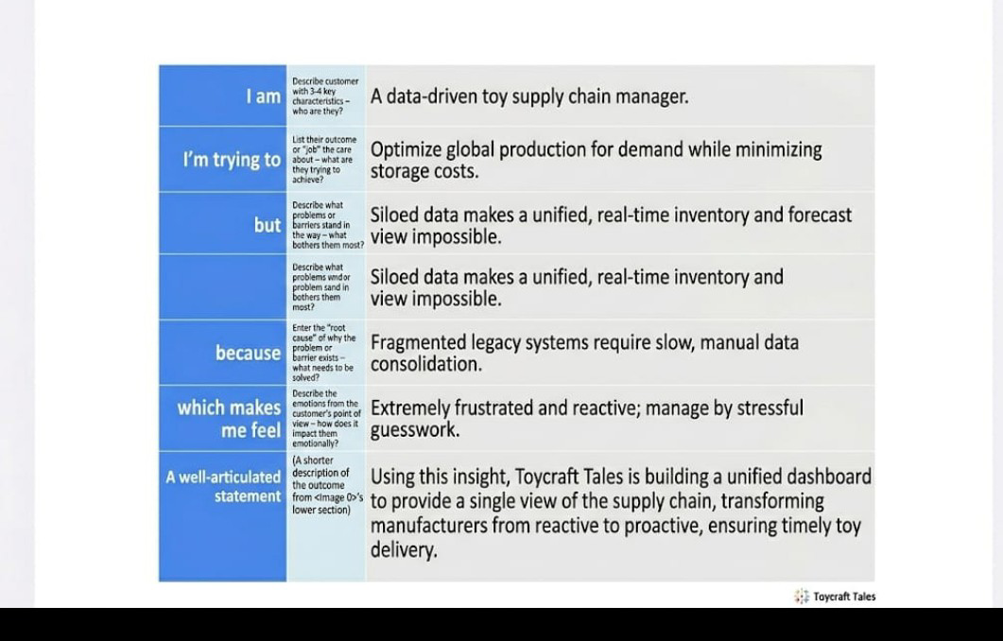

**Reference** :<https://miro.com/templates/customer-problem-statement/>

**Example :**

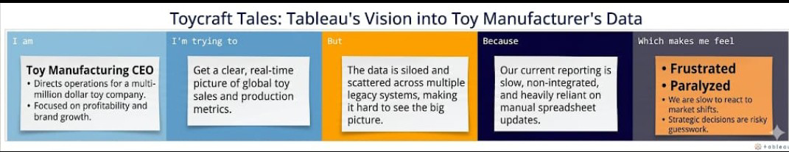

|  |  |  |  |  |  |
| --- | --- | --- | --- | --- | --- |
| **Problem statement (PS)** | **I am**  **(Customer)** | **I’m trying to** | **But** | **Because** | **Which makes me feel** |
| PS-1 | Toy Manufacturing CEO | Get a clear, real-time picture of global toy sales and production metrics | The data is siloed and scattered across multiple legacy systems | Our current reporting is slow and heavily reliant on manual spreadsheet updates | Frustrated and Paralyzed |
| PS-2 | Supply Chain Manager | Optimize inventory levels to meet seasonal toy demand | I cannot see the "big picture" of current stock versus forecastedsales | Systems are non-integrated, making it hard to see real-time Data | Stressed and reactive to market shifts |

**2.2 Empathy Map Canvas**

**Empathy Map Canvas**

**Definition** :

* An Empathy Map is a collaborative visual tool used to articulate what a team knows about a particular type of user.
* It externalizes user knowledge in order to create a shared understanding of user needs and aid in decision-making.
* The map is divided into sections that capture what the user Thinks & Feels, Sees, Says & Does, and Hears, along with their Pains and Gains.

**Purpose:**

* Understand the User: To help teams better understand their users by seeing things from the user's perspective.
* Identify True Problems: To identify the real challenges and goals a user experiences, which is essential for creating an effective solution.
* Team Alignment: To help participants consider the user's goals and challenges together, ensuring the whole team is focused on the same user needs.

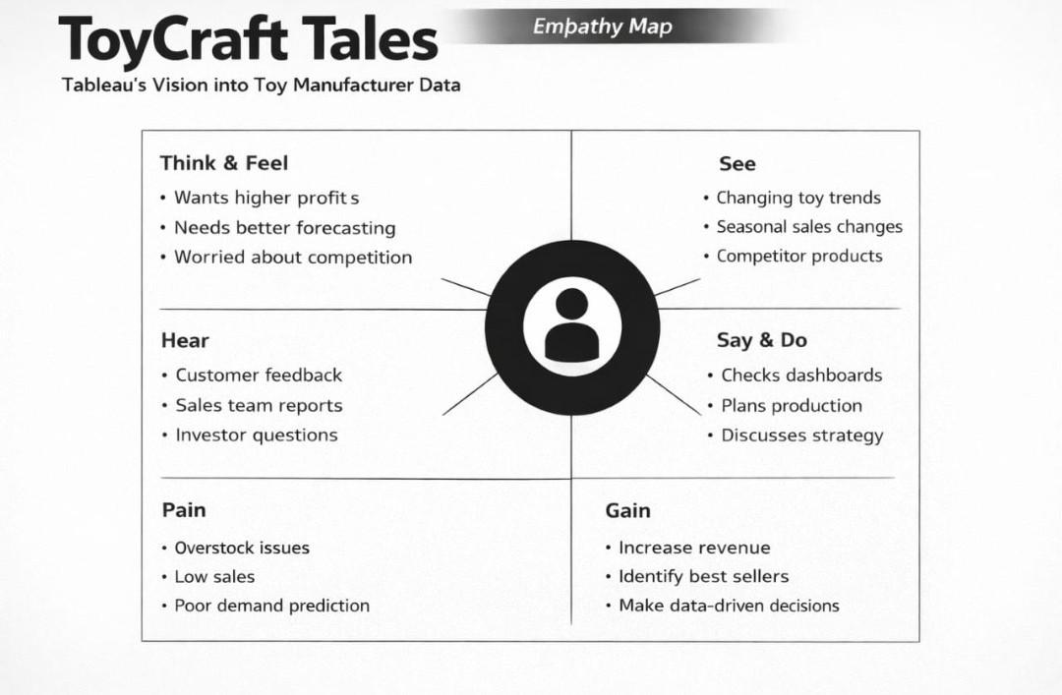

**Reference**: <https://www.mural.co/templates/empathy-map-canvas>

**Example** :

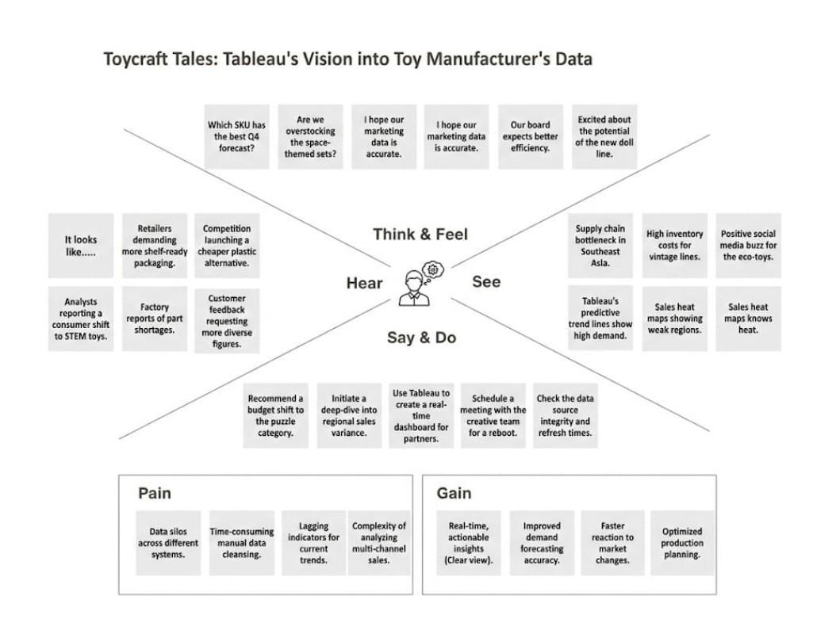

**2.3 Brainstorming**

**Brainstorm & Idea Prioritization Template:**

Brainstorming provides a free and open environment that encourages everyone within a team to participate in the creative thinking process that leads to problem solving. Prioritizing volume over value, out-of-the-box ideas are welcome and built upon, and all participants are encouraged to collaborate, helping each other develop a rich amount of creative solutions.

Use this template in your own brainstorming sessions so your team can unleash their imagination and start shaping concepts even if you're not sitting in the same room.

Reference: <https://www.mural.co/templates/brainstorm-and-idea-prioritization>

**Step-1: Team Gathering, Collaboration and Select the Problem Statement**

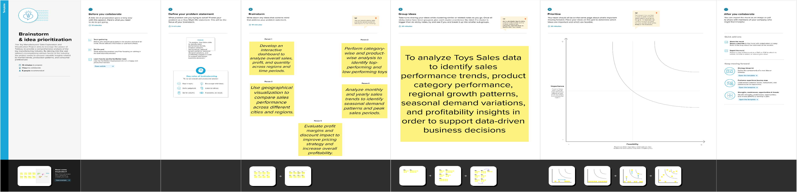

**Step-2: Brainstorm, Idea Listing and Grouping**

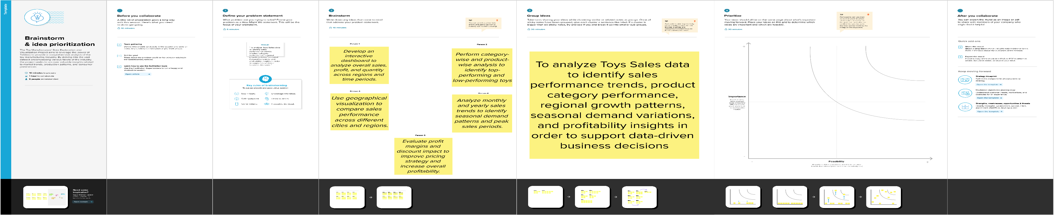

**Step-3: Idea Prioritization**

**Brainstorm & Idea Prioritization Template:**

Brainstorming provides a free and open environment that encourages everyone within a team to participate in the creative thinking process that leads to problem solving. Prioritizing volume over value, out-of-the-box ideas are welcome and built upon, and all participants are encouraged to collaborate, helping each other develop a rich amount of creative solutions.

Use this template in your own brainstorming sessions so your team can unleash their imagination and start shaping concepts even if you're not sitting in the same room.

Reference: <https://www.mural.co/templates/brainstorm-and-idea-prioritization>

**Step-1: Team Gathering, Collaboration and Select the Problem Statement**



**Step-2: Brainstorm, Idea Listing and Grouping**



**Step-3: Idea Prioritization**

3. **REQUIREMENT ANALYSIS**

**3.1 Customer Journey map**

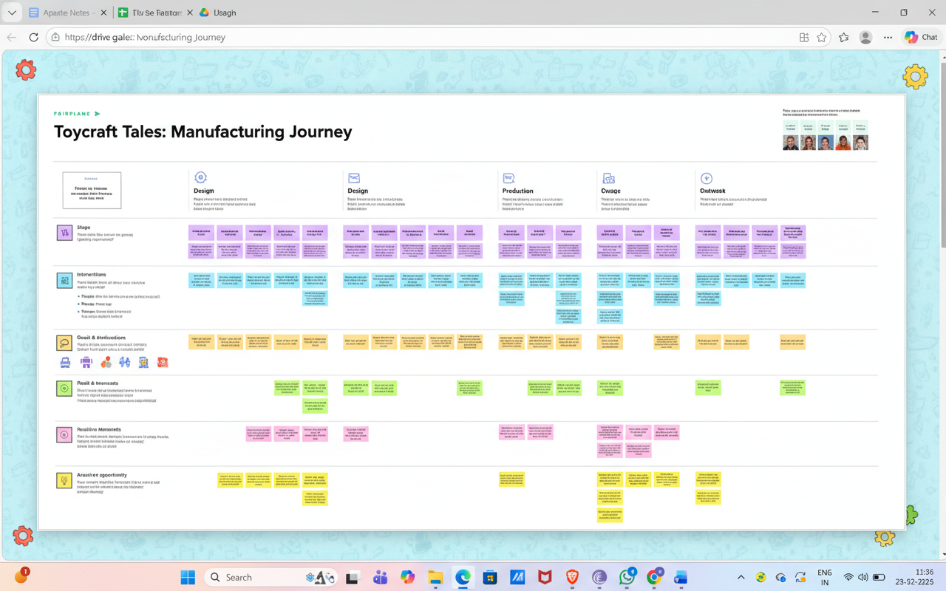

**3.2 Solution Requirement**

**Functional Requirements:**

Following are the functional requirements of the proposed solution.

|  |  |  |
| --- | --- | --- |
| FR No. | Functional Requirement (Epic) | Sub Requirement (Story / Sub-Task) |
| FR-1 | User Registration | Registration through Form  Registration through Gmail  Registration through LinkedIN |
| FR-2 | User Confirmation | Confirmation via Email  Confirmation via OTP |
| FR-3 | Data Dashboards &Data visualization | Tableau's Dashboards integration, Real-time Data sync, Interactive charts for toy sales |
| FR-4 | Manufactures Reports | Exportable PDF/Excel Report , trend analysis of Toycraft categories ,filter by region |
|  |  |  |
|  |  |  |

**Non-functional Requirements:**

Following are the non-functional requirements of the proposed solution.

|  |  |  |
| --- | --- | --- |
| **FR No.** | **Non-Functional Requirement** | **Description** |
| **NFR-1** | **Usability** | User-friendly UI based on Tableau dashboards that even non-technical staff can use. |
| **NFR-2** | **Security** | Secure authentication and role based access to protect sensitive manufacture data. |
| **NFR-3** | **Reliability** | The system should provide 99% accuracy in data synchronisation from manufacturing source. |
| **NFR-4** | **Performance** | dashboards and data reports should load within 3-5 seconds . |
| **NFR-5** | **Availability** | The platform from should be accessible 24/7 for global manufactures. |
| **NFR-6** | **Scalability** | Capable of handling increasing volumes of manufacture Data as the project Grows |

**3.3 Data Flow Diagram**

**Data Flow Diagrams:**

A Data Flow Diagram (DFD) is a traditional visual representation of the information flows within a system. A neat and clear DFD can depict the right

amount of the system requirement graphically. It shows how data enters and leaves the system, what changes the information, and where data is stored

**Example: (Simplified).**

**FLOW**

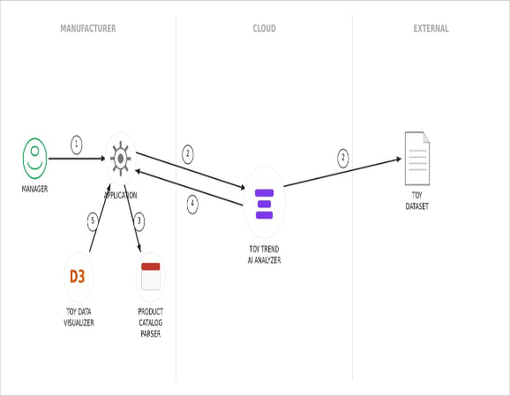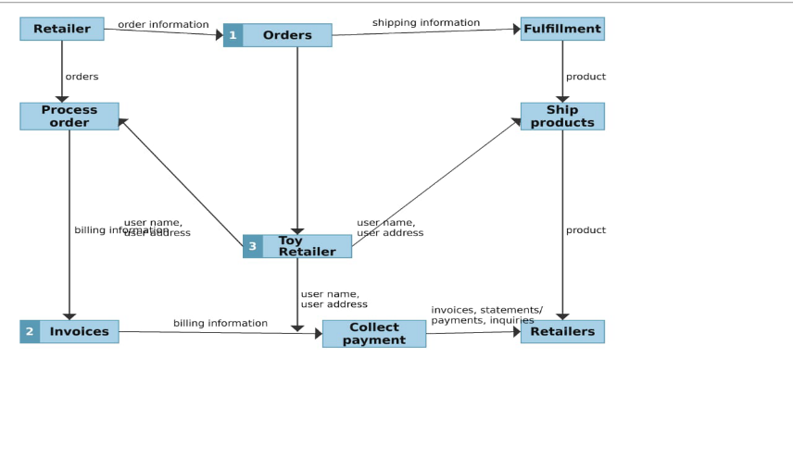

* Request Initiation: The Manager triggers the process by sending a command (1) to the local Application.
* Cloud Analysis: The Application communicates (2) with the Toy Trend AI Analyzer in the cloud, which pulls data from an External Toy Dataset.
* Local Parsing: The Application sends data (3) to the Product Catalog Parser to structure internal product information.
* Data Integration: The AI Analyzer returns the processed trend results (4) back to the central Application.

**User Stories**

Use the below template to list all the user stories for the product.

|  |  |  |  |  |  |  |
| --- | --- | --- | --- | --- | --- | --- |
| User Type | Functional  Requiremen(Epic) | User Story  Number | User Story / Task | Acceptance criteria | Priority | Release |
| Customer (Web User) | Dashboard | USN-1 | As a user, I can register for the application by  entering my email, password, and confirming my password | I can see a "Top Trends" bar chart that updates based on sales data. | Medium | Sprint-1 |
| Customer (Web User) | Dashboard | USN-2 | As a user, I want to filter toy data by age group to find relevant gift ideas. | The dashboard filters results instantly when an age range is selected. | Low | Sprint-2 |
| Customer Care Executive | Inventory Tracking | USN-3 | As an executive, I want to check real-time stock levels to answer customer availability queries. | I can search for a toy by ID and see the exact stock count across warehouses. | High | Sprint-1 |
| Customer Care Executive | Feedback Analysis | USN-4 | As an executive, I want to see a sentiment chart of toy reviews to identify quality issues. | A word cloud or sentiment bar shows common customer complaints/praise. | Medium | Sprint-2 |
| Administrator | Data Management | USN-5 | As an admin, I want to upload monthly factory production data to update the visuals. | The dashboard reflects new data within seconds of a CSV upload. | High | Sprint-1 |
| Administrator | Strategic Vision | USN-6 | As an admin, I want to view a geographical heatmap to see which regions have low sales. | A map visualization shows sales volume by city/region using color gradients. | High | Sprint-1 |
| Administrator | Cost Analysis | USN-7 | As an admin, I want to compare manufacturing costs vs. retail price to find profit margins. | A scatter plot displays the "Profit Gap" for every toy category. | Medium | Sprint-2 |

**3.4 Technology Stack**

**Technical Architecture:**

The Deliverable shall include the architectural diagram as below and the information as per the table1 & table 2

**Example: Order processing during pandemics for offline mode**

**Reference:** [**https://developer.ibm.com/patterns/ai-powered-backend-system-for-order-processing-during-pandemics/**](https://developer.ibm.com/patterns/ai-powered-backend-system-for-order-processing-during-pandemics/)

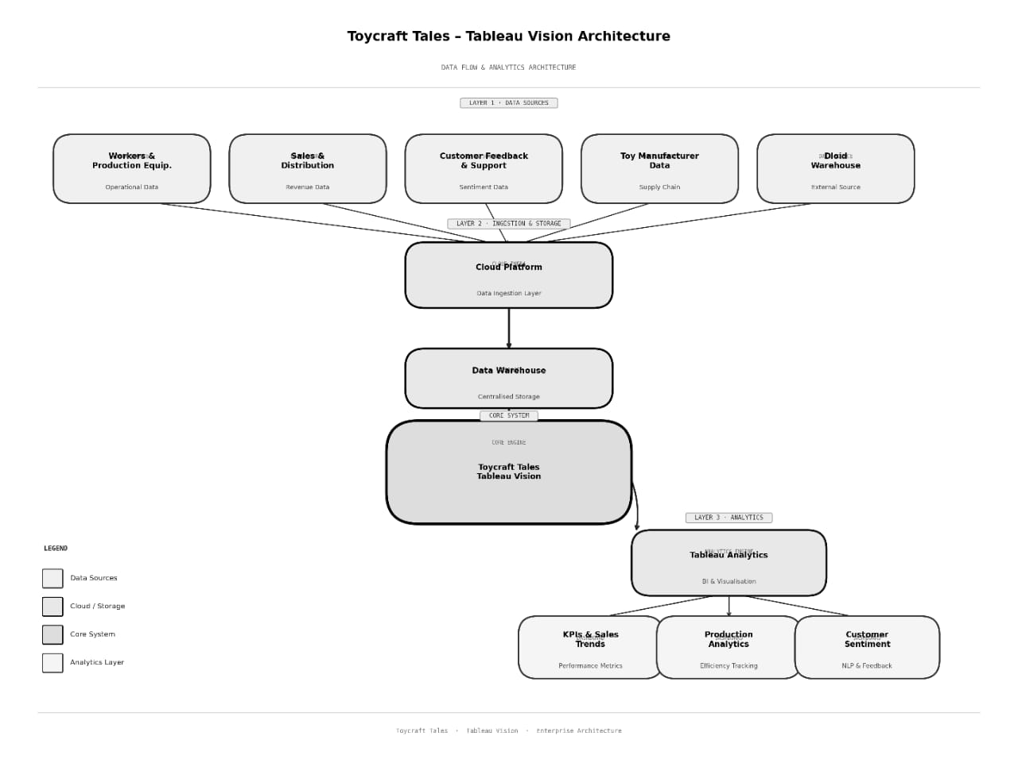

**Table-1 : Components & Technologies:**

|  |  |  |  |
| --- | --- | --- | --- |
| **S.no** | **Components** | **Description** | **Technology** |
| **1.** | User Interface | How user interacts with application e.g.  Web UI, Mobile App, Chatbot etc. | HTML, CSS, JavaScript / Angular Js / React Js etc. |
| **2.** | Application Logic**-**2 | Logic for a process in the application | Java / Python |
| **3.** | Application Logic-2 | Logic for a process in the application | IBM Watson STT service |
| **4.** | Application Logic-3 | Logic for a process in the application | IBM Watson Assistant |
| **5.** | Database | Data Type, Configurations etc. | MySQL, NoSQL, etc. |
| **6.** | Cloud Database | Database Service on Cloud | IBM DB2, IBM Cloudant etc. |
| **7.** | File Storage | File storage requirements | IBM Block Storage or Other Storage Service or Local Filesystem |
| **8.** | External API-1 | Purpose of External API used in the application | IBM Weather API, etc. |
| **9.** | External API-2 | Purpose of External API used in the application | Aadhar API, etc. |
| **10.** | Machine Learning Model | Purpose of Machine Learning Model | Object Recognition Model, etc. |
| **11.** | Infrastructure (Server / Cloud) | Application Deployment on Local System / Cloud  Local Server Configuration:  Cloud Server Configuration : | Local, Cloud Foundry, Kubernetes, etc. |

**Table-2: Application Characteristics:**

|  |  |  |  |
| --- | --- | --- | --- |
| **S.no** | **Characteristics** | **Description** | **Technology** |
| **1.** | Open-Source Frameworks | List the open-source frameworks used | Technology of Opensource framework |
| **2.** | Security Implementations | List all the security / access controls implemented, use of firewalls etc. | e.g. SHA-256, Encryptions, IAM Controls, OWASP etc. |
| **3.** | Scalable Architecture | Justify the scalability of architecture (3 – tier, Micro-services) | Technology used |
| **4.** | Availability | Justify the availability of application (e.g. use of load balancers, distributed servers etc.) | Technology used |
| **5.** | Performance | Design consideration for the performance of the application (number of requests per sec, use of Cache, use of CDN’s) etc. | Technology used |

**References**:

[**https://c4model.com**/](https://c4model.com/)

[**https://developer.ibm.com/patterns/online-order-processing-system-during-pandemic/**](https://developer.ibm.com/patterns/online-order-processing-system-during-pandemic/)

[**https://www.ibm.com/cloud/architecture**](https://www.ibm.com/cloud/architecture)

[**https://aws.amazon.com/architecture**](https://aws.amazon.com/architecture)

[**https://medium.com/the-internal-startup/how-to-draw-useful-technical-architecture-diagrams-2d20c9fda90d**](https://medium.com/the-internal-startup/how-to-draw-useful-technical-architecture-diagrams-2d20c9fda90d)

**4. PROJECT DESIGN**

**4.1 Problem Solution Fit :**

**Problem – Solution Fit Template: Toycraft Tales**

The Problem-Solution Fit for Toycraft Tales means identifying the specific operational pain points of toy manufacturers and proving that our Tableau-driven data analytics effectively solves them. This helps manufacturers move from "guesswork" to "data-backed decisions.”

**Purpose:**

* **Solve Complex Manufacturing Issues**: Addressing production delays and inventory imbalances in a way that aligns with the current workflow of toy factory managers.
* **Faster Market Success**: Increasing the adoption of new toy designs by tapping into existing customer buying patterns and seasonal trends discovered through data.
* **Sharpened Communication:** Using data triggers (like low stock alerts or high demand shifts) to refine marketing strategies and retail messaging for specific toy categories.
* **Enhanced Trust & Touch-points**: Building long-term reliability with retailers by solving "urgent or costly" problems like overstocking unpopular toys or missing out on viral toy trends.
* **Optimized Target Group Strategy**: Deeply understanding the current market situation to improve toy safety, pricing, and play-value for children and parents.

**Templates:**

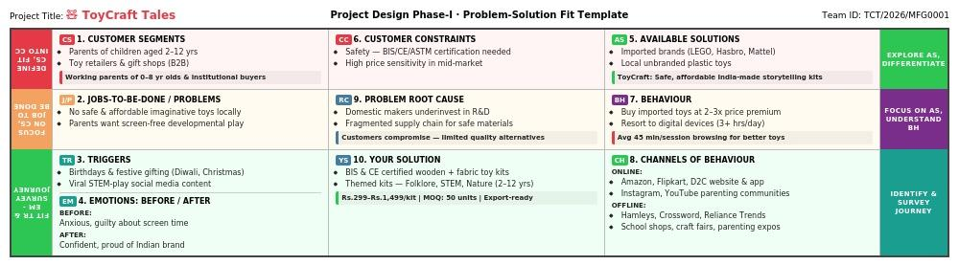

**References:**

**1.** [**https://www.ideahackers.network/problem-solution-fit-canvas/**](https://www.ideahackers.network/problem-solution-fit-canvas/)

**2.**[**https://medium.com/@epicantus/problem-solution-fit-canvas-aa3dd59cb4fe**](https://medium.com/@epicantus/problem-solution-fit-canvas-aa3dd59cb4fe)

**4.2 Proposed Solution**

**Proposed Solution Template:**

Project team shall fill the following information in the proposed solution template.

|  |  |  |
| --- | --- | --- |
| S.No | Parameter | Description |
| 1 | Problem Statement (Problem to be solved) | Toy manufacturers struggle to track sales trends and inventory, leading to overstocking or product shortages. |
| 2 | Idea / Solution description | An interactive Tableau Dashboard that visualizes real-time sales, production data, and seasonal demand. |
| 3 | Novelty / Uniqueness | Uses Data Storytelling to turn complex manufacturing numbers into actionable "tales" for better decision-making. |
| 4 | Social Impact / Customer Satisfaction | Reduces plastic waste by optimizing production and ensures customers find the toys they need in stock. |
| 5 | Business Model (Revenue Model) | A Subscription-based Analytics Service (SaaS) for small to mid-sized toy manufacturing companies. |
| 6 | Scalability of the Solution | The framework can be easily adapted for other retail sectors like Apparel or Electronics manufacturing. |

**4.3 Solution Architecture**

**Solution Architecture:**

Solution architecture in ToyCraft Tales is a structured process that connects toy manufacturing business challenges with powerful data-driven solutions using Tableau.It helps transform raw toy industry data into meaningful insights for smarter decision-making.

* External Entities: Any third-party data sources (like the Toy Trend Dataset).
* Integration Points: How the Application "talks" to the AI (usually via APIs).
* Security Gates: Firewalls or Authentication layers that protect the manufacturer's internal data.
* Data Sinks: Where the final "Tableau" or visualization is stored after the D3 Visualizer finishes its work.

**Key Components to Include**

* External Entities: Any third-party data sources (like the Toy Trend Dataset).
* Integration Points: How the Application "talks" to the AI (usually via APIs).
* Security Gates: Firewalls or Authentication layers that protect the manufacturer's internal data.
* Data Sinks: Where the final "Tableau" or visualization is stored after the D3 Visualizer finishes its work.

**Example - Solution Architecture Diagram:**

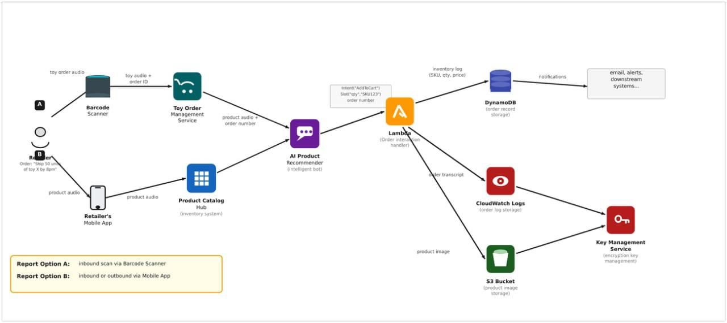

**Figure 1: Architecture and data flow of the voice patient diary sample application**

**Reference:**

[**https://aws.amazon.com/blogs/industries/voice-applications-in-clinical-research-**](https://aws.amazon.com/blogs/industries/voice-applications-in-clinical-research-)

**powered-by-ai-on-aws-part-1-architecture-and-design-considerations/**

**5. PROJECT PLANNING & SCHEDULING**

**5.1 Project Planning**

**Product Backlog, Sprint Schedule, and Estimation (4 Marks)**

Use the below template to create product backlog and sprint schedule

| **Sprint** | **Functional Requirement (Epic)** | **User Story Number** | **User Story / Task** | **Story Points** | **Priority** | **Team Members** |
| --- | --- | --- | --- | --- | --- | --- |
| Sprint-1 | Data collection & extraction from database | USN-6 | As a sales manager ,I want to see a map of sales by region so that I can identify which toy categories are trending in specific cities. | 3 | High | Jajjimoggala. Gangotri |
| Sprint-1 | Data preparation | USN-7 | As a warehouse lead,I want to see real -time stock levels of best- selling toys so that I can prevent “ out- of-stock “scenarios during peak seasons. | 2 | High | Potnuru.meghana |
| Sprint-2 | Dashboard | USN-8 | As a marketing executive, I want to filter toy sales by age group ( e.g 3-5 years,6-10years)to better target our next ad campaign. | 2 | Medium | Ganthi.Gopika |
| Sprint-1 | Story | USN-9 | As a finance officer,I want to compare the manufacturing cost vs.selling price per toy to see which products have the highest profit margins. | 3 | High | Gouda.Deepika |
| Sprint-1 | Performance testing | USN-10 | As a business analyst,I want to see a 6- month sales for caste based on historical data to plan raw material order for the next quarter. | 5 | Medium | Janapareddi.pooja |
|  | Web integration | USN-11 | As a dashboard user,I want to click on a specific toy image and see its individual performance metrics instantly. | 2 | Low |  |

**6. FUNCTIONAL AND PERFORMANCE TESTING**

**6.1 Performance Testing**

Model Performance Testing:Project team shall fill the following information in model performance testing template.

|  |  |  |
| --- | --- | --- |
| S.No. | Parameter | Screenshot / Values |
|  | Data Rendered | US Toy Manufacturers Dataset (CSV/Excel format) including state-wise and year-wise manufacturer counts. |
|  | Data Preprocessing | Handled null values in 'Index' column, cleaned State names, and ensured 'Year' was formatted as a Date/Discrete dimension. |
| 3. | Utilization of Filters | Year (Range/Slider), State (Multiple values dropdown), and Index Category (High, Medium, Low). |
| 4. | Calculation fields Used | Count of Index, Growth Rate %, and Index Binning (Categorizing manufacturers into performance tiers). |
| 5. | Dashboard design | No of Visualizations / Graphs: 4 (e.g., Map Chart for US states, Line Chart for Yearly Trends, Bar Chart for Top 10 States, and Pie Chart for Index Distribution).- |
| 6 | Story Design | No of Visualizations / Graphs: 5-6 Story Points (Individual points explaining: Industry Evolution, Geographical Performance, and Top Performers). |

**7. RESULTS**

**7.1 Output Screenshots**

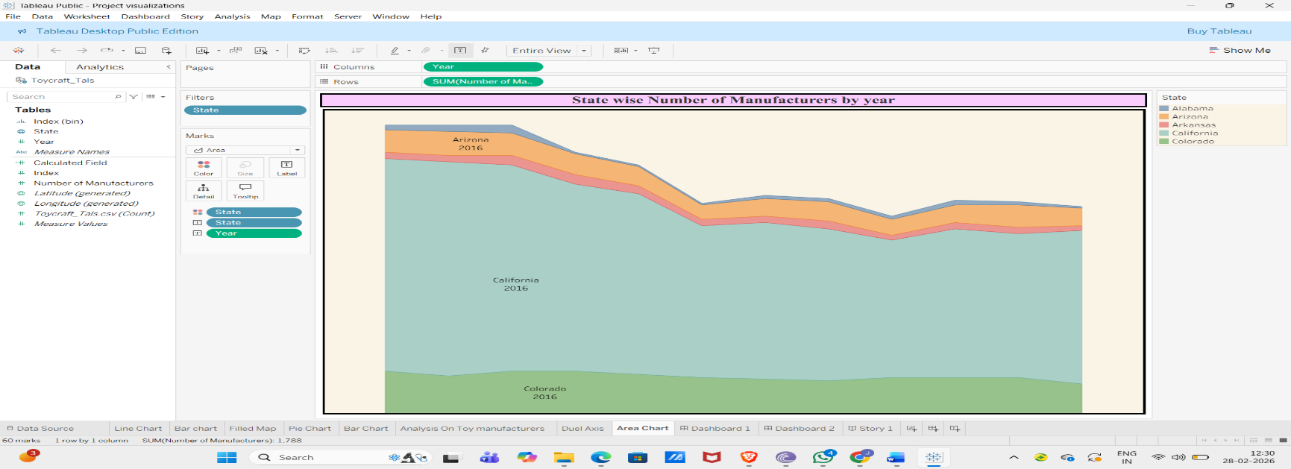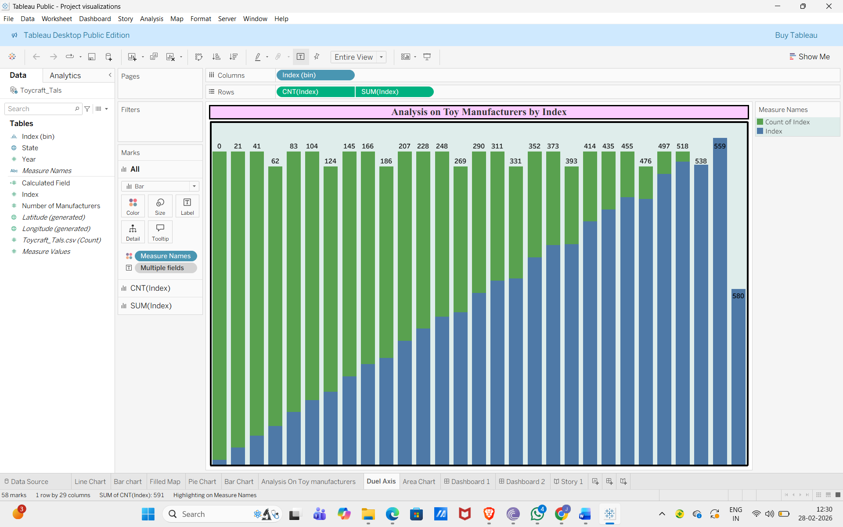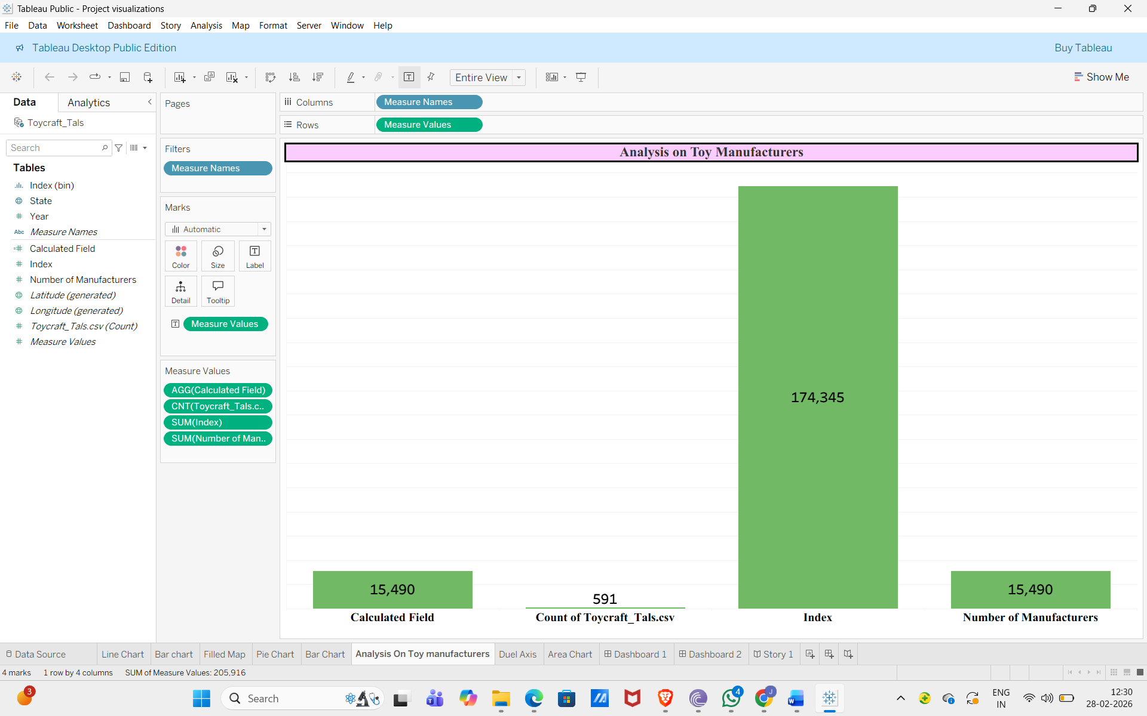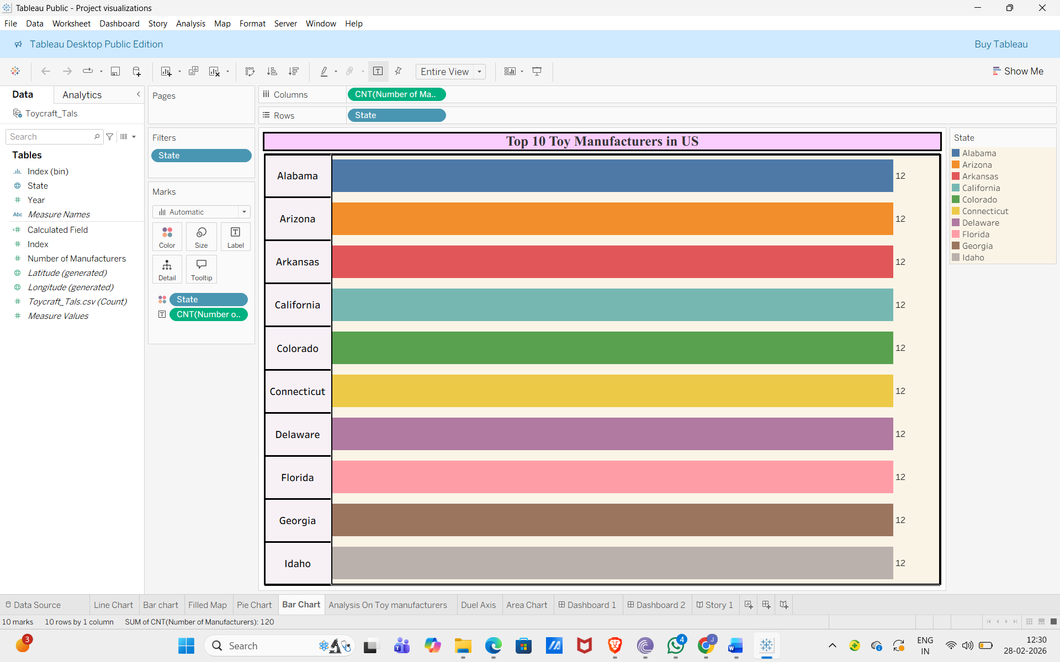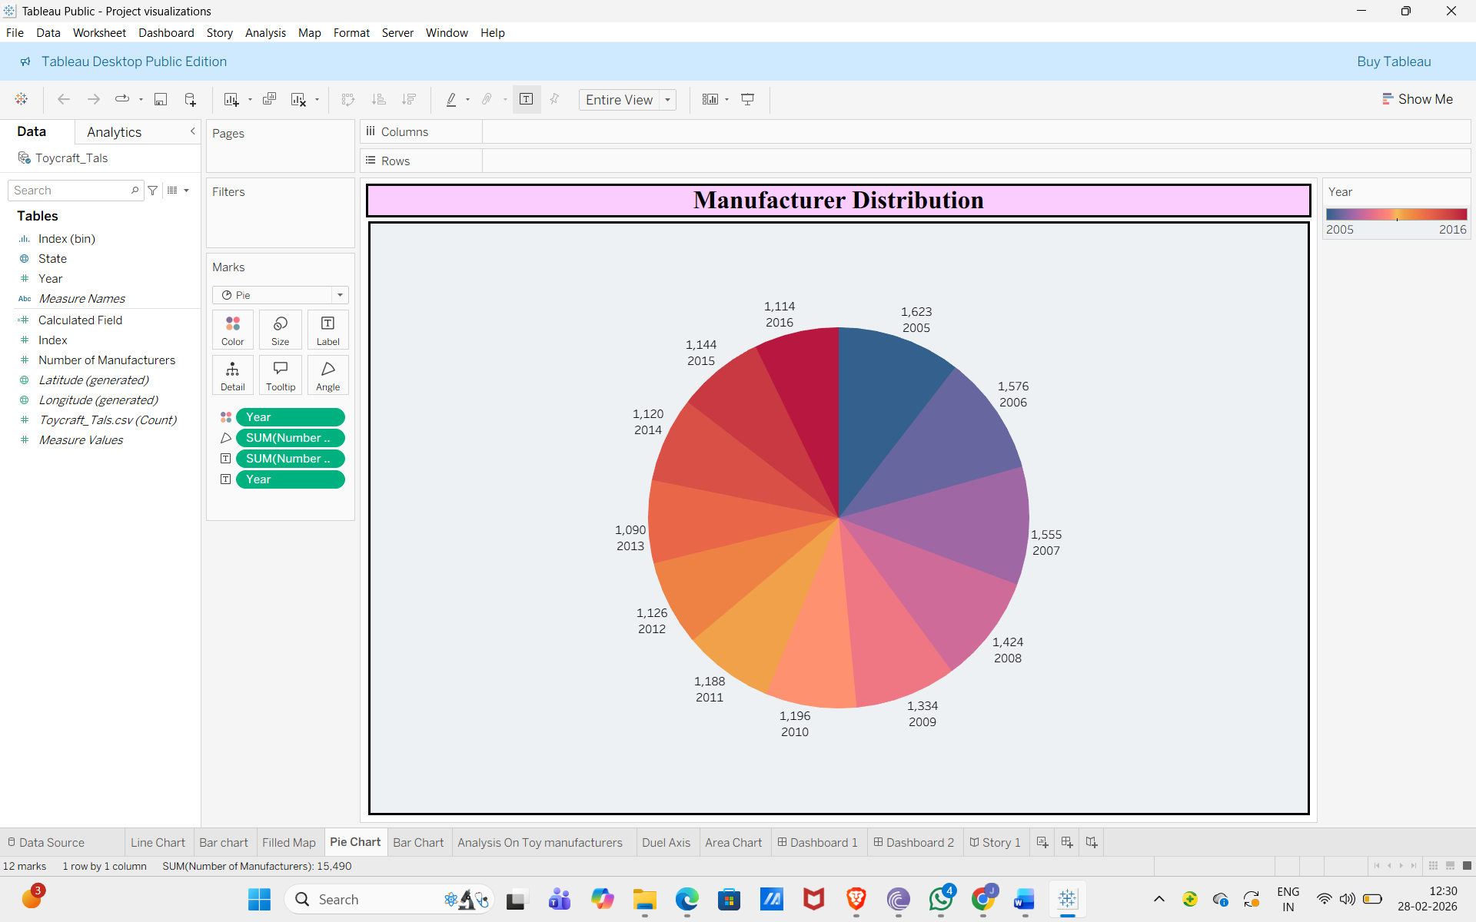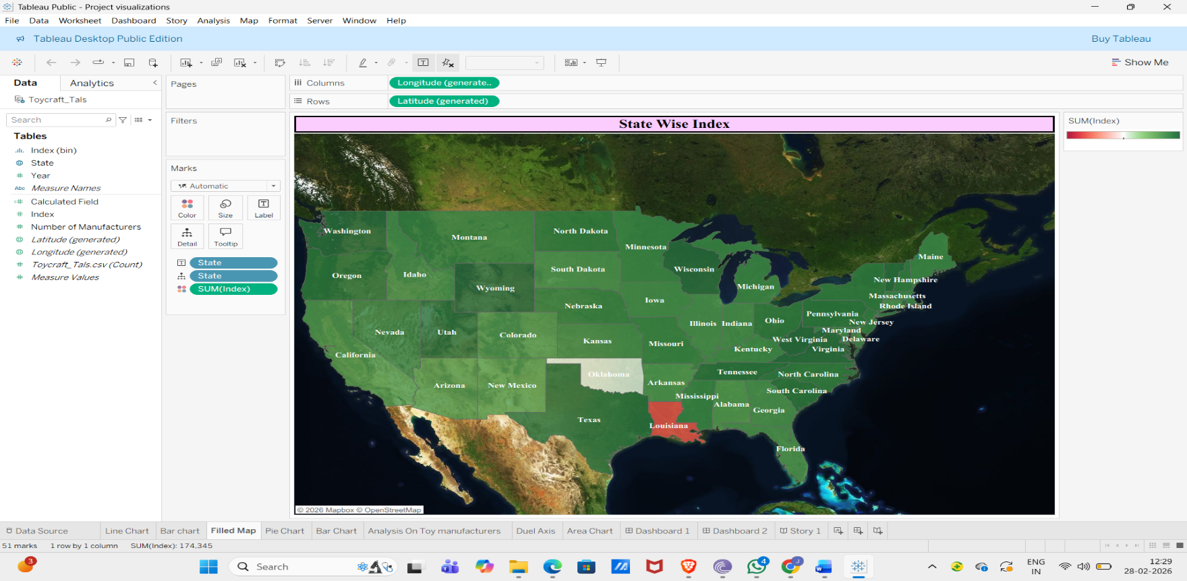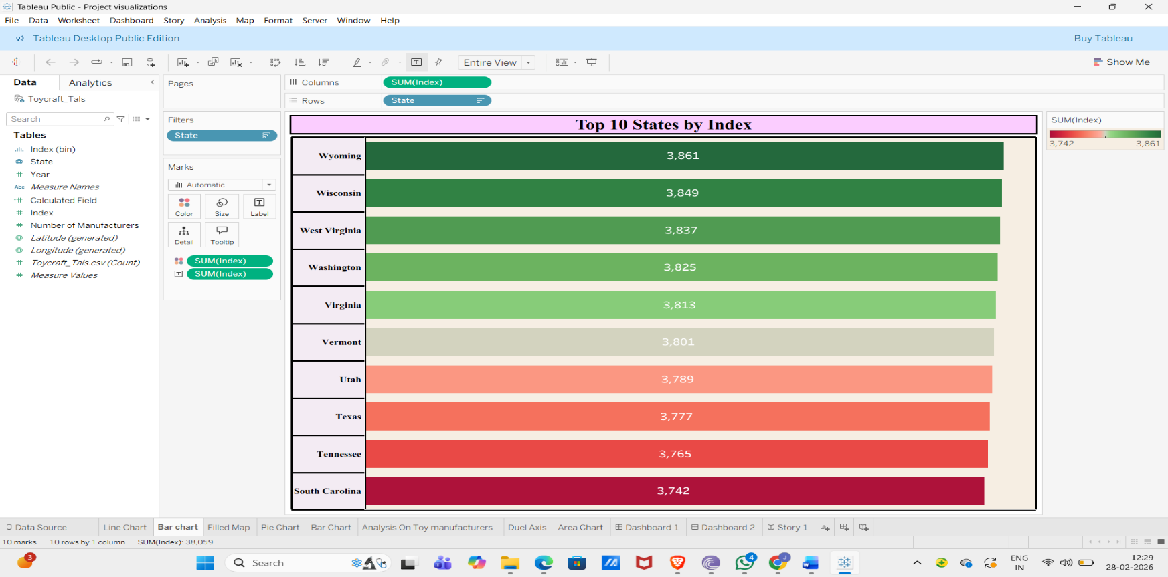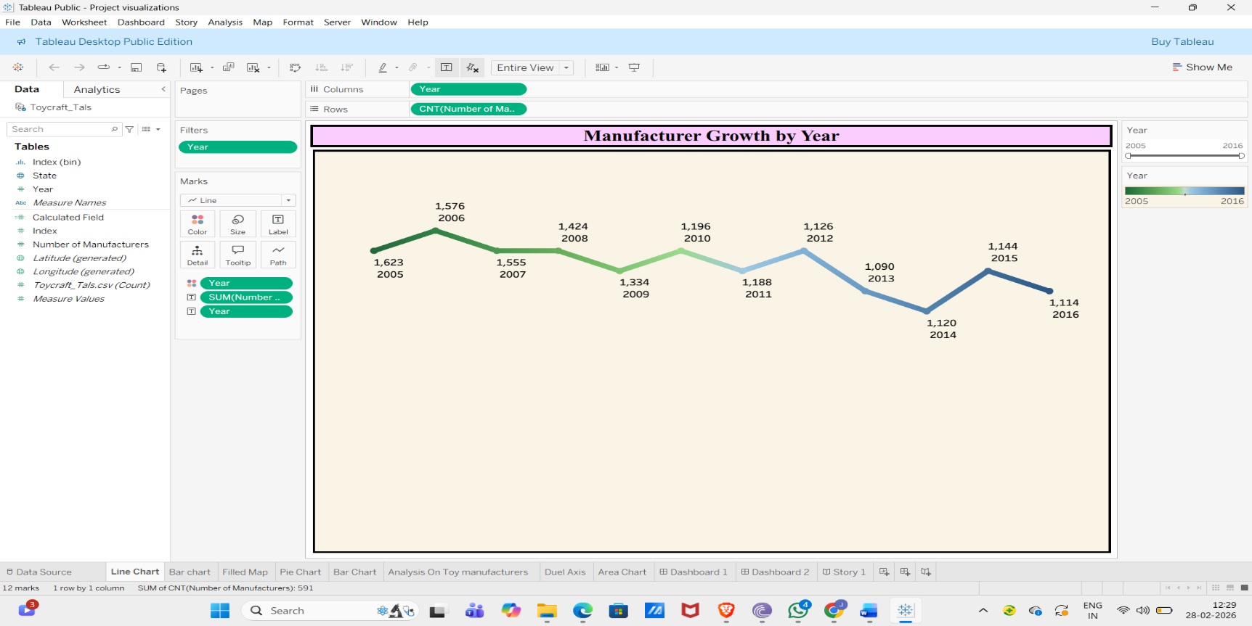

**8. ADVANTAGES & DISADVANTAGES**

**Advantages of the Toys Sales Analysis Project**

* Helps identify top-performing products and categories.
* Provides clear insights into regional and monthly sales trends.
* Supports data-driven decision-making for management.
* Improves inventory planning during peak seasons.
* Enhances understanding of customer purchasing behavior.
* Helps optimize pricing and profit margins.
* Visual dashboards make complex data easy to understand.

**Disadvantages of the Project**

* Analysis depends completely on the accuracy of available data.
* Historical data may not always predict future trends accurately.
* Limited dataset may not represent real market conditions.
* Requires technical knowledge of Tableau and data analysis tools.
* Does not include real-time data updates.

**9. CONCLUSION**

The Toys Sales Analysis Project successfully demonstrates how data visualization and analytical techniques can be used to transform raw sales data into meaningful business insights. By analyzing product categories, regional performance, monthly trends, payment methods, and profit margins, the project provides a clear understanding of overall business performance.

Through the use of Tableau dashboards and visualizations, complex datasets are presented in an easy-to-understand format, enabling better interpretation and faster decision-making. The analysis helps identify top-performing products, high-revenue regions, seasonal demand patterns, and profitability distribution.

This project highlights the importance of data-driven decision-making in modern business environments. Instead of relying on assumptions, management can use visual insights to optimize inventory, improve marketing strategies, adjust pricing models, and enhance customer satisfaction. Overall, the project proves that data analytics plays a crucial role in improving operational efficiency and increasing profitability in the retail industry.

**10. FUTURE SCOPE**

The future scope of this project is broad and promising. The current analysis is based on historical sales data; however, it can be further enhanced by integrating real-time data sources to provide live dashboards and up-to-date business insights.

Advanced analytical techniques such as predictive analytics and machine learning can be implemented to forecast future sales trends, predict seasonal demand, and improve inventory management. Customer segmentation analysis can also be introduced to provide personalized recommendations and targeted marketing strategies.

Additionally, the project can be integrated with web applications using tools like Flask to develop an interactive online dashboard accessible to management from anywhere. Automation features such as scheduled reporting and alert systems can further improve efficiency.

In the long term, this system can evolve into a complete Business Intelligence solution that supports strategic planning, improves customer experience, and drives sustainable business growth.

**11. APPENDIX**

**Source Code(if any)**

Flask Folder link:

[https://drive.google.com/drive/folders/1oB7Rn3p4o0BpQuw1YMsuo_RutFz8hjcs](https://drive.google.com/drive/folders/15rsaL9NZIK_kHbJVc-nmkV9vI_TCx5Rs?usp=sharing)

**Dataset Link**

Dataset Link:

[Toycraft_Tals.csv.xlsx](https://1drv.ms/x/c/5b30909964ba1d99/IQDvdi3EdgKQR53MafI9I06IAcjUwc9oVpEdBfuGq2ULdZU?e=B6pUYw)

**GitHub & Project Demo Link**

**Project Demo Public Link:** <https://drive.google.com/file/d/1xKdXaKVNQ8KbOuikuYvs8RFJnhhUJv2L/view?usp=sharing>

**Dashboard Public Link:**

<https://public.tableau.com/shared/4FSC8M87J?:display_count=n&:origin=viz_share_link>

**Story Public Link:**

<https://public.tableau.com/shared/C74TNZTNY?:display_count=n&:origin=viz_share_link>